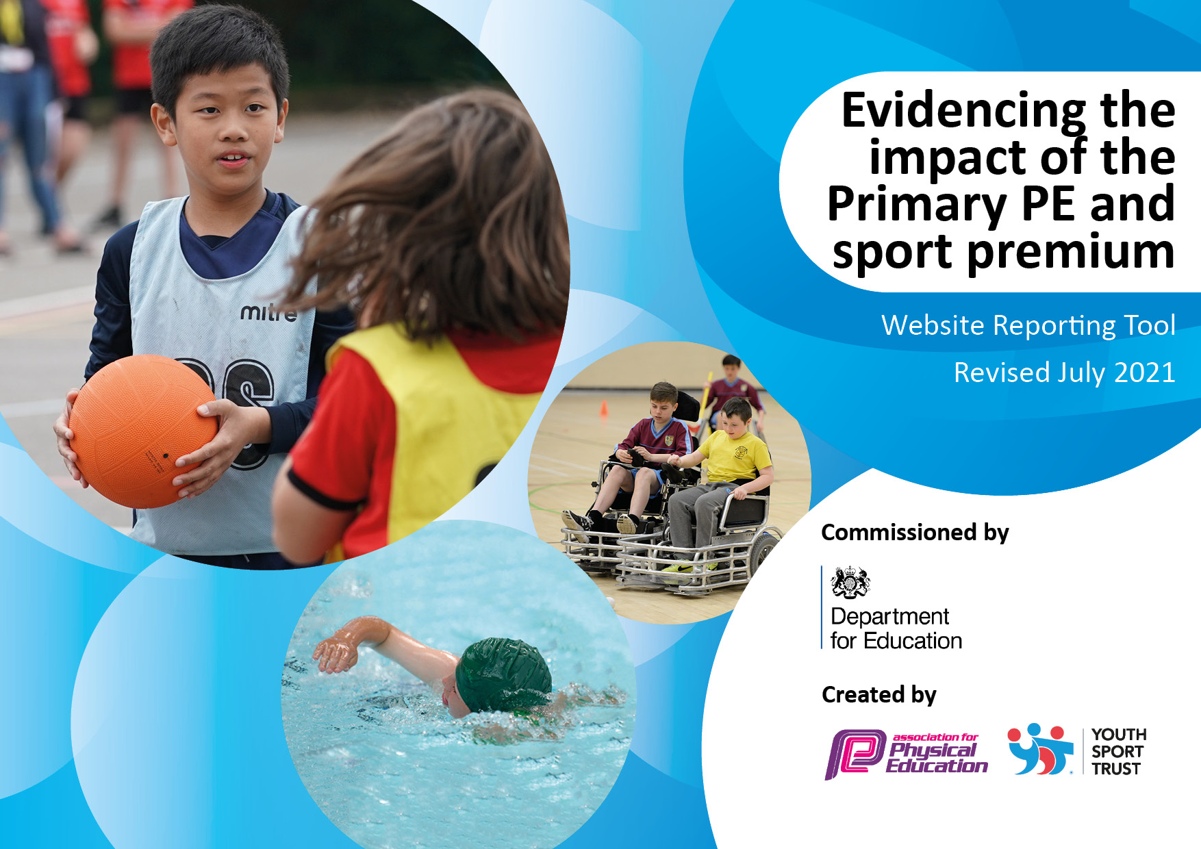
-------------------------------------------------------------
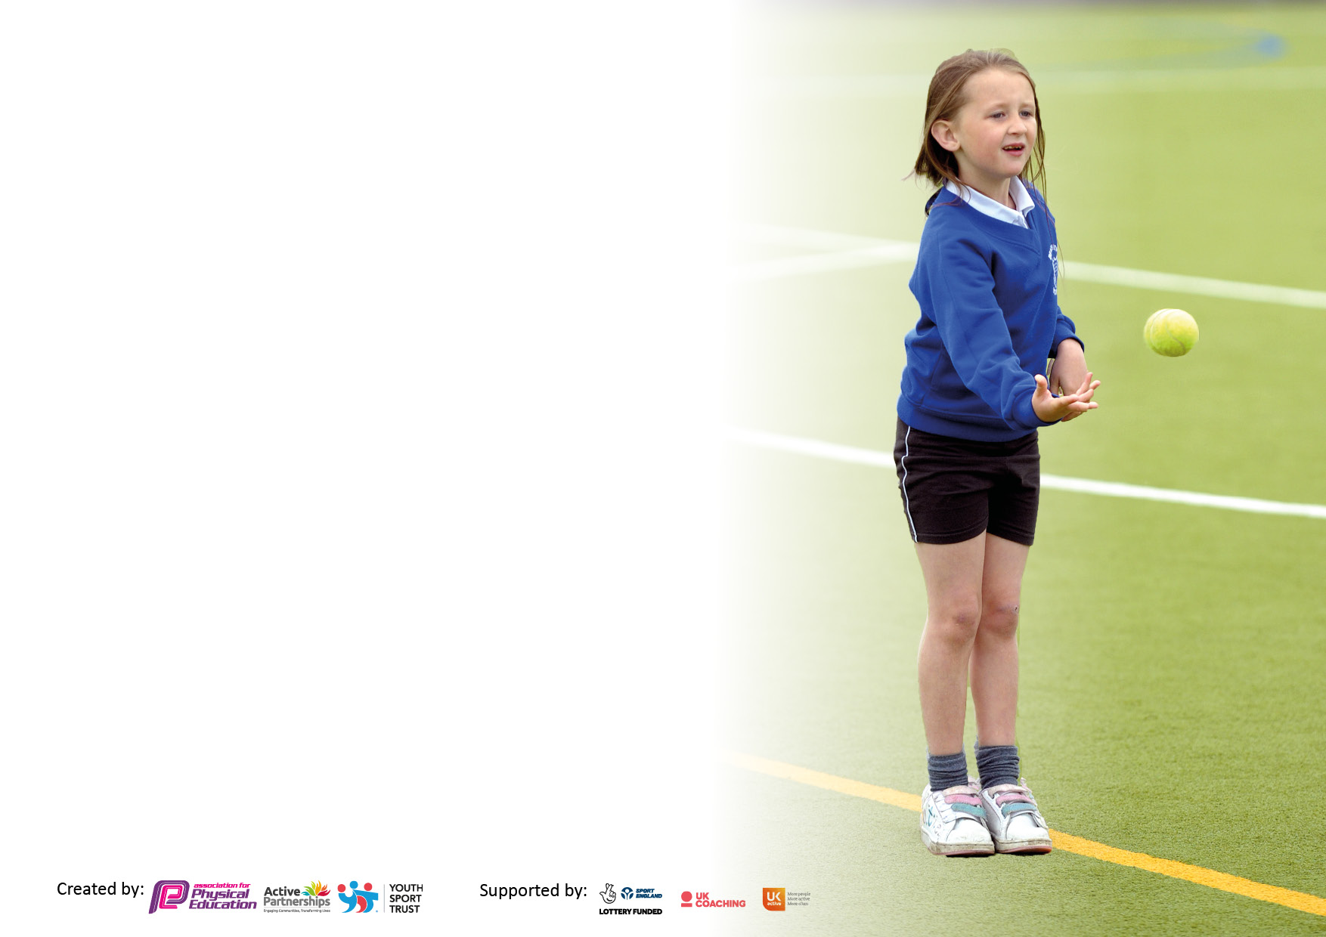

It is important that your grant is used effectively and based on school need. The Education Inspection Framework makes clear there will be a focus on ‘whether leaders and those responsible for governors all understand their respective roles and perform these in a way that enhances the effectiveness of the school’.

Under the Quality of Education Ofsted inspectors consider:
Intent - Curriculum design, coverage and appropriateness
Implementation - Curriculum delivery, Teaching (pedagogy) and Assessment
Impact - Attainment and progress

To assist schools with common transferable language this template has been developed to utilise the same three headings which should make your plans easily transferable between working documents.

Schools must use the funding to make additional and sustainable improvements to the quality of Physical Education, School Sport and Physical Activity (PESSPA) they offer. This means that you should use the Primary PE and sport premium to:

- Develop or add to the PESSPA activities that your school already offer
- Build capacity and capability within the school to ensure that improvements made now will benefit pupils joining the school in future years
- The Primary PE and sport premium should not be used to fund capital spend projects; the school’s budget should fund these.

Pleasevisitgov.ukfortherevisedDfEguidanceincludingthe5keyindicatorsacrosswhichschoolsshoulddemonstrate animprovement.Thisdocumentwillhelpyoutoreviewyourprovisionandtoreportyourspend.DfEencouragesschools to use this template as an effective way of meeting the reporting requirements of the Primary PE and sport premium.

We recommend you start by reflecting on the impact of current provision and reviewing the previous spend.

Schools are required to publish details of how they spend this funding, including any under-spend from 2019/2020, as well as on the impact it has on pupils’ PE and sport participation and attainment. All funding must be spent by 31st July 2022.

We recommend regularly updating the table and publishing it on your website throughout the year. This evidences your ongoing self-evaluation of how you are using the funding to secure maximum, sustainable impact. Final copy must be posted on your website by the end of the academic year and no later than the 31st July 2021. To see an example of how to complete the table please click HERE.
Created by: Supported by:

Details with regard to funding
Please complete the table below.
Bishop Sutton Primary School
Total amount carried over from 2020/21 | £0
Total amount allocated for 2021/22 | £17,510
How much (if any) do you intend to carry over from this total fund into 2022/23? | £0
Total amount allocated for 2022/23 | £17,550
Total amount of funding for 2022/23. To be spent and reported on by 31st July 2023. | £17,550
Stanton Drew Primary School
Total amount carried over from 2020/21 | £0
Total amount allocated for 2021/22 | £16,450
How much (if any) do you intend to carry over from this total fund into 2022/23? | £0
Total amount allocated for 2022/23 | £16,530
Total amount of funding for 2022/23. To be spent and reported on by 31st July 2023. | £16,530
Swimming Data
Please report on your Swimming Data below.

Meeting national curriculum requirements for swimming and water safety.

N.B. Complete this section to your best ability. For example you might have practised safe self-rescue techniques on dry land which you can then transfer to the pool when school swimming restarts.
Due to exceptional circumstances priority should be given to ensuring that pupils can perform safe self rescue even if they do not fully meet the first two requirements of the NC programme of study
What percentage of your current Year 6 cohort swim competently, confidently and proficiently over a distance of at least 25 metres?  Can jump into the swimming pool and tread water.  Can swim with clothes on.  N.B. Even though your pupils may swim in another year please report on their attainment on leaving primary school | Bishop Sutton Stanton Drew  92% 100%

Action Plan and Budget Tracking
Capture your intended annual spend against the 5 key indicators. Clarify the success criteria and evidence of impact that you intend to measure to evaluate for pupils today and for the future.
Key Achievements to date until July 2023 | Areas for further development and baseline evidence needed:
1. A range of clubs taking place after school including; football, cricket, netball, athletics, basketball, street hockey, multisports and gymnastics.  2. High quality teaching in every year group each week; all children have two PE lessons a week and daily physical activities.  3. Active play leader at lunchtime and at after school club to encourage outdoor play and team building working with all classes.  4. Play Leader (adult and child) to promote mental health wellbeing through lunchtime sessions.  5. Local Sporting events we have participated have included netball, cross country, hockey and football as well as dance festivals and tournaments, festivals and competitions as part of the Chew Valley School Sports Partnership  6. Passionate children who have engaged in various sporting opportunities provided  7. High success rate of competent swimmers by the end of KS2  8. We offer our children the opportunity to attend a wide range of after school sports clubs with financial support available for pupil premium children (as well as others at SDPS)  10. Walk to school and scooter/cycle encouraged  11.Children who have not completed their 25m by the end of Y4 to be targeted in Y5 to achieve this by the end of KS2. | 1. Review fitness levels and children’s preparedness to participate in physical activities  4.Create more local links with outside clubs.  5.Develop other games such as bowling/badminton/table tennis to explore other sports and games to be more inclusive.  6.Develop additional opportunities for the Daily Mile and other daily physical activities  8.Review assessment procedures in collaboration with specialist staff.  9.New PE scheme introduced – support teachers and allow for greater consistency in the delivery of PE  10.From Key indicators to continue to monitor and explore:  The engagement of all pupils in regular physical activity – review DPA and ensure variation as well as simple monitoring for DPA and assessment procedures  The profile of PESSPA being raised across the school as a tool for whole school improvement – updated noticeboards for sports and DPA  Increased confidence, knowledge and skills of all staff in teaching PE and sport – investigate introduction of REAL PE Scheme (LSP Trust Schools recommended scheme)  Broader experience of a range of sports and activities offered to all pupils – continue to research additional sports opportunities for in-school and after school provision  Increased participation in competitive sport – use additional admin/office time to liaise with other schools and add to annual planner
Academic Year: 2022/23 | Total fund allocated: | Date Updated:
Key indicator 1: The engagement of all pupils in regular physical activity – Chief Medical Officers guidelines recommend that primary school pupils undertake at least 30 minutes of physical activity a day in school |  |  |  | Percentage of total allocation:
 |  |  |  | %
Intent | Implementation |  | Impact
Your school focus should be clear what you want the pupils to know and be able to do and about  what they need to learn and to  consolidate through practice: | Make sure your actions to achieve are linked to your intentions: | Funding allocated: | Evidence of impact: what do pupils now know and what can they now do? What has changed?: | Sustainability and suggested next steps:
- That all children have high quality PE sessions in school with a range of sports and development of skills (this includes teachers and outside sport agencies having clear progression across year groups and confidence to teach PE)  - Children to have 2 hours of PE sessions or physical activity per week  - To provide a stimulating lunchtime environment which encourages and promotes physical activity both in a structured and non-structured format  - Targeted clubs and groups to increase the engagement and participation to encourage everyone to be active (Such as girls sports, PP and SEN) | All children will have two PE sessions a week.  Alongside this daily movement will be in place in each class (wake and shake and brain breaks).  Regularly audit PE resources to make sure staff have what is needed to deliver high quality lessons.  Check against long term planning to what resources are needed.  Higher trained staff (PH Sports) to deliver active playtimes during lunchtime and after school club.  Children to have access to a variety of resources at lunchtime including the play pod, different sport resources eg. Basket balls and hoops, rackets and balls.  A range of sports clubs offered throughout the year. | See Appendix One below | Using new PE resources ‘PE Planning’ to give teachers high quality ideas for their lessons.  Most teachers do extra movement within their teaching day e.g. wake and shakes, daily movement breaks, lunchtime activities, choice for golden time.  PE sports offer play leader games during 1 lunchtime per week which lead to higher participation in physical activity during these lunchtimes.  Year 6 children became play leaders in term 5 and 6 and lead class sport activities, which again lead to increased physical activity during these lunchtimes.  We’ve had good participation of sporting clubs with a good mix of children.  We have also had a broad range of traditional and untraditional clubs to offer more variety. | New PE scheme being introduced 23-24, where all teachers will have access to high quality lesson plans, monitoring of progress and a clear progression of skills throughout each year group.  All classes will have two PE slots each week to reach 2 hours of physical activity each week.  PH sports to continue with their play leader role for one lunchtime a week.  Year 6 children will have play leader training and an opportunity to run class sporting games and activities during term 5 & 6.  To continue to have a range of clubs on offer throughout the school year. Work on getting more PP children in some of these clubs.
Key indicator 2: The profile of PESSPA being raised across the school as a tool for whole school improvement |  |  |  | Percentage of total allocation:
 |  |  |  | %
Intent | Implementation |  | Impact
Your school focus should be clear what you want the pupils to know and be able to do and about  what they need to learn and to  consolidate through practice: | Make sure your actions to achieve are linked to your intentions: | Funding allocated: | Evidence of impact: what do pupils now know and what can they now do? What has changed?: | Sustainability and suggested next steps:
- To raise the profile of sports and PE within the schools and to participate in tournaments and festivals organised by the Chew Valley Partnership as a means of promoting physical activity and offering a greater variety of sporting activities and skills based learning. Children to experience a range of alternative sports.  - To develop leadership skills in years 5 & 6  - Mindfulness and checking in with emotions daily part of the school day. | All classes (Y1-Y6) have the opportunity to take part in at least one CVS sporting festival across the year.  Each class (R-Y6) have an opportunity to attend an alternative sport at Mendip Outdoor Pursuits.  A range of after school clubs offered.  Playleader roles offered in term 5 & 6 for children to lead small sessions at lunchtimes to younger classes.  New ‘Zones of regulation’ introduced in each class. | See Appendix One below | Increased participation in all sports in all key stages through CVS festivals.  All classes had a trip to Mendip Outdoor Pursuits and enjoyed taking part in an alternative sports for the day/morning.  We’ve had good participation of sporting clubs with a good mix of children.  We have also had a broad range of traditional and untraditional clubs to offer more variety.  Zones of regulation has been a clear way for children to check in with their emotions and age appropriate strategies to help come back into the ‘green’ zone. | - Continue to take children to sporting festivals, alternative sporting trips and a variety of after school clubs offered.  - Invite Inspirational adults to lead whole-school assembly to inspire the children.  - Zones of regulation will be consistently used across all classes and multiple daily ‘check in’s’ are done.

Key indicator 3: Increased confidence, knowledge and skills of all staff in teaching PE and sport |  |  |  | Percentage of total allocation:
 |  |  |  | %
Intent | Implementation |  | Impact
Your school focus should be clear | Make sure your actions to | Funding | Evidence of impact: what do | Sustainability and suggested
what you want the pupils to know | achieve are linked to your | allocated: | pupils now know and what | next steps:
and be able to do and about | intentions: |  | can they now do? What has
what they need to learn and to |  |  | changed?:
consolidate through practice:
- To teach high quality PE sessions with a range of skills and sports. This will also help increase core values such as fairness and respect.  - Purchase of additional resources to run alongside current PE planning and training to support less confident teachers with their PE teaching. | PE sessions are linked with the key learning cogs (personal, social, cognitive, health and fitness)  PE Planning – for resources to support teachers who are less confident teaching PE.  Support given for those teachers who are less confident teaching PE. | See Appendix One below | PE leader had support from outside agency to develop a new whole school PE curriculum – starting 23-24 which will have progression and consistency for each class.  New resources bought (PE Planning) to support teachers with their planning and teaching before buying a full new scheme in 23-24. | To use new whole school curriculum map which will build progression across the school.  Develop confidence in using new PE scheme (PE Hub) for all teacher and outside agencies who teach PE lessons.  Provide effective CPD for all staff using the new PE scheme.
Key indicator 4: Broader experience of a range of sports and activities offered to all pupils |  |  |  | Percentage of total allocation:
Intent | Implementation |  | Impact
Your school focus should be clear | Make sure your actions to | Funding | Evidence of impact: what do | Sustainability and suggested
what you want the pupils to know | achieve are linked to your | allocated: | pupils now know and what | next steps:
and be able to do and about | intentions: |  | can they now do? What has
what they need to learn and to |  |  | changed?:
consolidate through practice:
- To raise the profile of sports and PE within the schools and to participate in tournaments and festivals organised by the Chew Valley Partnership as a means of promoting physical activity and offering a greater variety of sporting activities and skills based learning. Children to experience a range of alternative sports.  - To promote a love of being physical and active outside by providing Forest School and outdoor learning opportunities for all children within the year. To increase and improve children's agility and stamina through the Forest school ethos | All classes (Y1-Y6) have the opportunity to take part in at least one CVS sporting festival across the year.  Each class (R-Y6) have an opportunity to attend an alternative sport at Mendip Outdoor Pursuits.  A range of after school clubs offered. | See Appendix One below | Increased participation in all sports in all key stages through CVS festivals.  All classes had a trip to Mendip Outdoor Pursuits and enjoyed taking part in an alternative sports for the day/morning.  We’ve had good participation of sporting clubs with a good mix of children.  We have also had a broad range of traditional and untraditional clubs to offer more variety.  Forest school is given to all reception and Y1 children. The KS1 children also attend ‘Folly Farm’ three times a year. | - Continue to take children to sporting festivals, alternative sporting trips and a variety of after school clubs offered.  - Continue to utilise the school forest for both schools

Key indicator 5: Increased participation in competitive sport |  |  |  | Percentage of total allocation:
 |  |  |  | %
Intent | Implementation |  | Impact
Your school focus should be clear | Make sure your actions to | Funding | Evidence of impact: what do | Sustainability and suggested
what you want the pupils to know | achieve are linked to your | allocated: | pupils now know and what | next steps:
and be able to do and about | intentions: |  | can they now do? What has
what they need to learn and to |  |  | changed?:
consolidate through practice:
- Give children the opportunity to participate in additional after school clubs with a range of sports.  - Membership Chew Valley School Sports Partnership to provide opportunity for children to participate in a range of sports at competition level.  - Use funding to provide quality coaches to prepare children for events and to deliver PE sessions in a range of sports (PH Sports and World Sports Ministries). | A range of new after school clubs are being offered to children, as well as pre-existing clubs.  Working with CVS sport festivals for all year groups  Disadvantaged children to have opportunities to represent the school in inter competitions.  Have regular coaches to teach classes to develop sport knowledge. | See Appendix One below | We’ve had good participation of sporting clubs with a good mix of children.  We have also had a broad range of traditional and untraditional clubs to offer more variety.  All children have attended sporting festivals to increase competitive sports. | With our new PE scheme starting 23-24 KS1 PE lessons skills based and KS2 PE lessons sport and skill based which will support them in competitive sporting events.  Continue to have outside agencies to deliver 1 PE session a week per class.

Appendix 1
Breakdown of all costs (committed and spent)

Bishop Sutton | Cost £ | Stanton Drew | Cost £
Resources  Travel costs to PE events  PH Sports Annual contract  PH Sports Math on the Move  Swimming  Tennis  WSM x3 pms a week  Total: | £500  £2523  £3819  £2888  £2120  £1140  £4560  £17550 | Resources  PE subscription per LJ for federation  Travel costs to PE events  PH Sports annual contract  PH Sports maths on the move  Swimming  Tennis  WSM 1x pm a week  Total: | £300  £165  £2500  £3819  £2888  £2120  £1140  £2280  £15212

Signed off by
Head Teacher:
Date:
Subject Leader: | Louise Jeffery
Date: | 13.08.23
Governor:
Date:

