Bishop Sutton Pupil premium strategy statement 2021-24

This statement details our school’s use of pupil premium (and recovery premium for the 2021 to 2022 academic year) funding to help improve the attainment of our disadvantaged pupils.

It outlines our pupil premium strategy, how we intend to spend the funding in this academic year and the effect that last year’s spending of pupil premium had within our school.

School overview
Detail | Data
School name | Bishop Sutton Primary School
Number of pupils in school | 169
Proportion (%) of pupil premium eligible pupils | 8.3%
Academic year/years that our current pupil premium strategy plan covers (3 year plans are recommended) | 2021/22 – 2024/25
Date this statement was published | December 2021
Date on which it will be reviewed | July 2022
Statement authorised by | Dieter Cook, Headteacher
Pupil premium lead | Andrew Marriott, Deputy Headteacher
Governor / Trustee lead | Simon Waller, Chair of Govs

Funding overview
Detail | Amount
Pupil premium funding allocation this academic year | £16,140
Recovery premium funding allocation this academic year | £2,000
Pupil premium funding carried forward from previous years (enter £0 if not applicable) | £0
Total budget for this academic year  If your school is an academy in a trust that pools this funding, state the amount available to your school this academic year | £18,140

Part A: Pupil premium strategy plan

Statement of intent
Our intention is that children at Bishop Sutton Primary School, disadvantaged or not, will be in receipt of high-quality teaching and learning opportunities that are carefully planned and sequenced with a strong pedagogical approach underpinning our curriculum offer. We will use proven educational research to support our strategic decision-making and day-to-day implementation of this plan. The primary aim will always be to narrow the gap for our most disadvantaged learners but we acknowledge that a benefit from this plan will include progress for all.
In our school, we recognise that eligibility for free school meals does not always equate with disadvantage and also that some of our most disadvantaged pupils may not qualify as pupil premium. This knowledge of individual pupils’ specific needs, which includes social and emotional as well as learning, is a key driver of how we target support.
Bishop Sutton Primary School is located in an affluent ward of Bath and North East Somerset and our numbers of pupil premium children have only shown a small increase since 2019 (12 in 2018-19, 10 in 2019-20, 13 in 2020-21, 14 at the date of this plan). The pandemic has disadvantaged children from a wide range of socio-economic backgrounds and as such determines how we intend to implement this plan.
The Lighthouse Schools’ Partnership Disadvantaged policy draws on evidence and research from the EEF to develop its policy. As a school we have developed our RAPP to build on these principles in order to deliver the best possible provision for our disadvantaged pupils. The Trust believes the most effective way to ensure equal opportunities for all is to remove the barriers to underachievement for identified pupils at the earliest possible opportunity.
The recent report by the Education Endowment Fund (EFF) entitled EEF Guide to the Pupil Premium 2019, as well as the EFF report entitled The Attainment Gap 2017) The Attainment Gap; and the previous joint report between the EEF and the Sutton Trust entitled Pupil Premium: The Next Steps (2015) all refer to the fact that the most effective learning opportunities for pupils who are disadvantaged are those that are based on early identification, high quality teaching, employment of proven and research based interventions which accelerate progress early on; and, importantly, learning that is tied in with ‘memorable experiences’.
Our approach has carefully considered the Trust Disadvantaged policy, and will also be responsive to individual needs to ensure no child is left behind because of disadvantage.
Our key principles are:
- A whole school approach where all stakeholders recognise, understand and take a role in improving outcomes for all children but especially the disadvantaged
- Rigorous monitoring to identify needs early, intervention wherever needs are first identified and consequent support and challenge to ensure improved outcomes
- Ensuring all children have an opportunity to be included in the full range of experiences being a child in our school can provide

Challenges

This details the key challenges to achievement that we have identified among our disadvantaged pupils.
Challenge number | Detail of challenge
1 | Assessment, observations and discussions with pupils suggest disadvantaged pupils generally have greater difficulties with phonics than their peers. This negatively impacts their development as readers.
2 | Summative assessments and Teacher judgements indicate that maths attainment among disadvantaged pupils is below that of non-disadvantaged pupils.  In Key Stage 1, the attainment gap in maths attainment is highest.
3 | Summative assessments and Teacher judgements indicate that Reading and Writing attainment among disadvantaged pupils is below that of non-disadvantaged pupils.  In Key Stage 1, the attainment gap in Reading and Writing attainment is highest.
4 | Assessment, observation and teacher judgements suggest that there is already a gap between disadvantaged and non-disadvantaged pupils by the end of the EYFS
5 | The gap in ‘cultural capital’ between disadvantaged and non-disadvantaged children in our school community can be pronounced due to affluence in our locality. The small number of disadvantaged children in each class (sometimes 1) and the school as a whole means they are at risk of being isolated from the life experiences of their peers.

Intended outcomes
This explains the outcomes we are aiming for by the end of our current strategy plan, and how we will measure whether they have been achieved.
Intended outcome | Success criteria
Improved reading attainment among disadvantaged pupils | Summative assessments (including PSC) show no statistically significant gap between disadvantaged and non-disadvantaged pupils.
Improved maths attainment among disadvantaged pupils | Summative assessments and Teacher judgements show improved outcomes from 2021 83% non-disadvantaged ARE and 54% disadvantaged ARE to a gap of <10% at most.
Improved Writing attainment among disadvantaged pupils | Teacher judgements show improved outcomes from 2021 74% non-disadvantaged ARE and 36% disadvantaged ARE to a gap of <10% at most.
Disadvantaged pupils in EYFS achieve similar attainment to non-disadvantaged pupils | Assessments of children show a narrowing of the gap between disadvantaged and non-disadvantaged (of 2021 disadvantaged pupils who were present in EYFS 50% achieved GLD. Non-disadvantaged 82%)
Disadvantaged pupils are given the opportunity to take part in extra-curricular activities | Records from after-school clubs show a high rate of attendance from disadvantaged pupils.

Activity in this academic year
This details how we intend to spend our pupil premium (and recovery premium funding) this academic year to address the challenges listed above.

Teaching (for example, CPD, recruitment and retention)
Budgeted cost: £ 4200
Activity | Evidence that supports this approach | Challenge number(s) addressed
Purchase of Nfer diagnostic assessments.  Additional training for staff to ensure results impact teaching | Standardised tests can provide reliable diagnostic insights to help ensure each pupil receives the correct additional support. They can also be instrumental in monitoring the impact of this support.  EEF guide to the Pupil premium 1 and 4 | 1,2,3
Involvement of teachers from across the school in Boolean Maths Hub work groups (DfE initiative through NCETM) Supply cover needed for release time to embed the mastery approach.  Use of Maths apps (TTRockstars and Numbots initially) to enhance curriculum offer | The DfE non-statutory guidance has been produced in conjunction with the National Centre for Excellence in the Teaching of Mathematics, drawing on evidence-based approaches:  Maths_guidance_KS_1_and_2.pdf (publishing.service.gov.uk)  Improving Mathematics in Key Stages 2 and 3  Early Years and Key Stage 1 Mathematics Teaching: Evidence Review | 2,4
Developing and enhancing teaching through the application of Cognitive Science approaches: A programme of CPD (Using Rosenshine and Teaching Walkthrus) | The EEF states in their July 2021 review that: Cognitive science principles of learning can have a real impact on rates of learning in the classroom. There is value in teachers having working knowledge of cognitive science principles.  EEF Cognitive Science approaches in the classroom:A review of the evidence | 1,2,3,4

Targeted academic support (for example, tutoring, one-to-one support structured interventions)
Budgeted cost: £ 10,500
Activity | Evidence that supports this approach | Challenge number(s) addressed
Additional phonics sessions targeted at disadvantaged pupils who require further phonics support | Phonics approaches have a strong evidence base indicating a positive impact on pupils, particularly from disadvantaged backgrounds. Targeted phonics interventions have been shown to be more effective when delivered as regular sessions over a period up to 12 weeks:  Phonics | Toolkit Strand | Education Endowment Foundation | EEF | 1,4
Engaging with the National Tutoring Pro-gramme to provide a blend of tuition, mentoring and school-led tutoring for pupils whose education has been most impacted by the pandemic. A significant proportion of the pupils who receive tutoring will be disadvantaged, including those who are high attainers. | Tuition targeted at specific needs and knowledge gaps can be an effective method to support low attaining pupils or those falling behind, both one-to-one:  One to one tuition | EEF (educationendowmentfoundation.org.uk)  And in small groups:  Small group tuition | Toolkit Strand | Education Endowment Foundation | EEF | 1,2,3,4
Enhanced hours and professional development for TAs to deliver targeted interventions | Research which focuses on teaching assistants who provide one to one or small group targeted interventions shows a stronger positive benefit of between four and six additional months on average. Often interventions are based on a clearly specified approach which teaching assistants have been trained to deliver.  EEF Teaching Assistant Interventions | 1,2,3,4

Wider strategies (for example, related to attendance, behaviour, wellbeing)
Budgeted cost: £ 3440
Activity | Evidence that supports this approach | Challenge number(s) addressed
Establish and monitor an inclusion strategy to ensure participation in the wider offer of school life, to include Arts participation | The impact of participation in creative Arts such as fine arts, drama, dance, poetry and creative writing is positive according to EEF.  EEF Teaching and Learning Toolkit | 5
Contingency fund for acute issues | Experience has shown that a small amount should be reserved for issues that are as yet unplanned. | All

Total budgeted cost: £ 18140

Part B: Review of outcomes in the previous academic year

Pupil premium strategy outcomes
This details the impact that our pupil premium activity had on pupils in the 2020 to 2021 academic year.
In 2020-21, our aims were: Improve mathematical fluency and reasoning skills so that progress is in line or better with Reading and Writing; Ensure a comprehensive programme of Phonics teaching and interventions are implemented and monitored in KS1.
The impact of these aims has been significantly affected by the pandemic. Although attendance of online lessons was strong and attendance by our vulnerable children was high, teachers taught from home and therefore interventions were not established. The following assessments in Maths, Reading and Writing are teacher judgements and were not moderated:
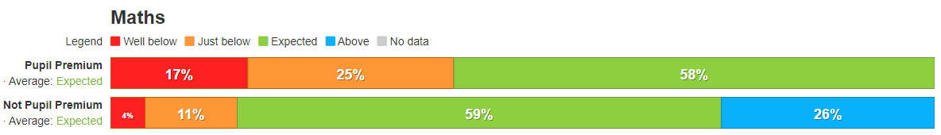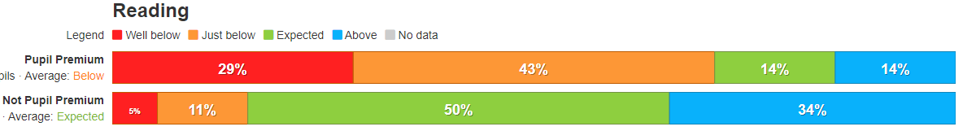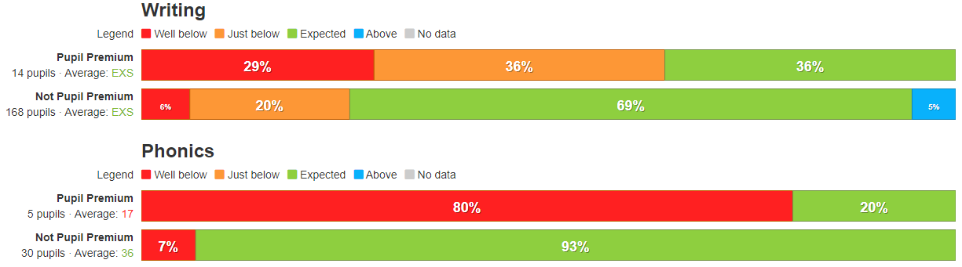Phonics is includes our own assessment (using a past PSC) of year 1 pupils and pupils in year 2 who would have had to retake the assessment.
Our assessment of the reasons for these outcomes points primarily to Covid-19 impact, which disrupted all our subject areas to varying degrees. As evidenced in schools across the country, school closure was most detrimental to our disadvantaged pupils, and they were not able to benefit from our pupil premium funded improvements to teaching and targeted interventions to the degree we had intended. The impact was mitigated by our resolution to maintain a high-quality curriculum, including during periods of partial closure, which was aided by use of online resources such as those provided by Oak National Academy.
Maths had been a focus across our Federation and staff had started to become involved with the Boolean Maths Hub, supported through NCETM. Training and support have been hugely impacted by the pandemic and there have been many changes to how the support would be delivered. These limitations affected our first aim.
We were successful in implementing Read, Write Inc as our Phonics scheme and this was supported by investment in new books and training for staff. Again, the pandemic meant that as of December 2021, we are yet to have taught a whole year using this as our SSP, meaning that the impact of it is challenging to measure.

Externally provided programmes
Programme | Provider
Thrive | Thethriveapproach.com

